CISC 352: Artificial Intelligence
Final Project Report
Vedansh Bhatt
20416335
April 15, 2026

CISC 352 – Final Report
Introduction
The game of chess has long piqued the interest of humans and robots alike. With tremendous growth in computing power in recent decades, alongside specialized supercomputer developments, the game has become a platform in which intelligence decision-making can be studied and evaluated. While chess engines calculate deep tactical variations, human enthusiasts reason about the state of the board at a higher strategic level, thinking about plans that may improve piece coordination, control key squares, or prepare an attack on the opponent. This project aims to study how artificial intelligence techniques can be used to evaluate these ideas.
The principal challenge arises from the sheer complexity of chess and the unpredictability of an opponent's response. Rather than evaluating isolated moves, our approach compares short candidate plans and uses several complementary evaluation signals to judge them. To address this problem, we integrate three foundational AI techniques discussed in this course: automated planning generates and ranks bounded continuations, probabilistic inference models uncertainty in strong opponent replies, and deep learning provides a learned position evaluator trained on Stockfish-labelled data.
In summary, the following project, entitled Before You Move, provides an experimental framework for comparing how the different AI techniques studied in this course evaluate candidate plans and predict their strategic effectiveness.
Problem Formulation
To tackle this problem, we model strategic decision-making in chess as a planning problem defined over board states and legal actions. Consider the following:
- A state corresponds to a chess position represented by its board configuration (FEN string)
- An action corresponds to legal moves available to the side whose turn it is to play
- A plan is a sequence of moves representing a specific idea or continuation
Since opponent responses are unknown, each plan branches out to a set of possible future states, and the objective of the system is to estimate which candidate plans are most promising under both heuristic evaluation and a learned evaluation model. In other words, the system is not a full chess engine; it is an AI workbench for comparing strategic continuations under multiple decision-making techniques.
AI Techniques
Automated Planning
Automated planning is the first technique used in Before You Move because the project is fundamentally about comparing candidate continuations rather than evaluating only a single move in isolation. At a high level, the planner receives a chess position, generates legal actions for the side to move, and explores a bounded search tree of short continuations. The goal is not to replicate a full-strength chess engine, but rather to produce a ranked set of strategically plausible short plans that a user can inspect and compare.
The implementation uses the python-chess library for board representation, move generation, SAN/UCI conversion, and safe push/pop simulation of hypothetical continuations. In this formulation, a state is a board position represented internally by a python-chess Board object and externally by a FEN string when needed for display or storage. An action is any legal move available from that state, and a plan is a finite sequence of actions obtained by recursively expanding the search tree to a fixed ply depth.
Formally, if s₀ is the root state and π = (a₁, a₂, ..., a_{d}) is a candidate plan of depth d, then the planner applies the actions in sequence to obtain a leaf state s_{d}. Each candidate plan is scored using a heuristic evaluation function E(s_{d}), and it is also summarized by a change score $Delta\left(π\right)=E\left(s_{d}\right)-E(s_{0})$. Plans are then ranked from the perspective of the root side: higher scores are better if white is to move at the root, while lower white-centric scores are better if black is to move at the root.
The heuristic evaluation function used by the planner is intentionally lightweight so that it can be called many times during interactive search. In the final version of the project, the evaluation is not pure material count. Instead, it can be summarized as a weighted sum of material, bishop pairs, board mobility, castling rights, and king safety. Material remains the dominant term, but the additional components allow the system to penalize strategically dubious choices such as walking the king into the centre in the middlegame, while remaining simple enough for real-time use in the user interface.
To keep the branching factor manageable, the planner does not uniformly expand every legal move. Instead, it uses a move-ordering heuristic that prioritizes captures, checks, and promotions before quieter moves. This ordering is useful because forcing moves are often tactically relevant and therefore good candidates to inspect first. The planner also applies separate branching limits for our moves and the opponent's moves, which makes the search more controllable and easier to explain from an AI perspective than an unrestricted brute-force tree.
One limitation of this planning approach is that it is still a bounded heuristic search rather than a full minimax engine with deep tactical calculation. As a result, the planner is best interpreted as a structured idea generator: it surfaces plausible candidate continuations and explains how they compare under the chosen evaluator, but it may still miss long tactical resources beyond the search horizon.
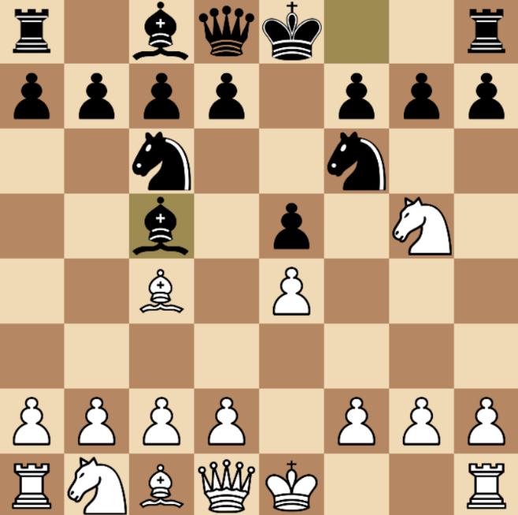
Figure 1: Fried Liver Attack – Nxf7 forks the Queen and Rook
In this position, all generated plans encourage white to capture on f7, as seen below:
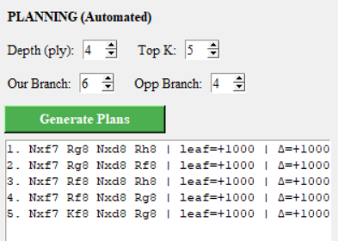
Figure 2: Top five plans generated for White
Probabilistic Inference
Probabilistic inference is used to model uncertainty in the opponent's reply. Even if the planner generates a promising candidate move, the actual usefulness of that move depends on how the opponent responds over the next few plies. The probabilistic module therefore estimates how often a candidate first move leads to a result that remains competitive against strong replies, rather than assuming a single deterministic continuation.
Let m denote a candidate first move from the root position. For each such move, the system runs multiple rollout simulations and estimates $P\left(good move | m\right)=\frac{successful rollouts(m)}{total rollouts(m)}$. A rollout produces a leaf score after a short horizon of additional plies, measured from the perspective of the player who moved at the root. This root-perspective conversion is important because the internal evaluator is white-centric, while the inference task must work correctly for either side to move.
The success event is defined relative to the best candidate move, not relative to the current position. If $avg leaf(m)$ is the average leaf score for move m and $best expected score = max⁡(avg_{leaf\left(m\right)})$, then the target threshold is $target score = best expected score - margin$. A rollout for move m is counted as successful when $leaf score(m) >= target_score$. This definition fixes an issue with the earlier version of the project: in defensive positions, every legal move may worsen the current evaluation, but one move can still clearly be the best practical response. Under the final definition, that move can still achieve a high near-best probability.
The rollout policy uses a simplified strong-opponent model. On our turns during the simulation, the system deterministically chooses the strongest move according to the heuristic evaluator. On the opponent’s turns, the system ranks legal replies, keeps the top K candidates, and samples among them using rank-based weights. In our implementation the default weights favour the best-ranked reply while still assigning probability mass to the next few moves, which models an opponent that is strong and consistent without assuming perfect engine play at every turn.
A limitation of this probabilistic model is that it is only as good as the rollout policy and evaluation function used inside the simulations. Since the rollouts are short and the opponent model is approximate, the resulting probabilities should be interpreted as comparative guidance rather than exact winning chances. Even so, they provide useful information that pure planning does not capture, namely how robust a move appears when strong counterplay is taken into account.
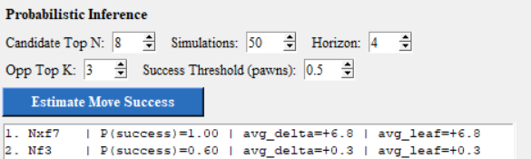
Figure 3: Estimated chances of success for the top two moves in the position shown in Figure 1
Deep Learning
Deep learning is used as a learned evaluation component that complements the handcrafted heuristic evaluator. Instead of manually specifying every positional factor, the neural model is trained to approximate Stockfish's scalar evaluation of a board position. This gives the system a data-driven signal that can generalize across many positions and detect patterns that are difficult to encode cleanly with a small set of manual rules alone.
The supervised learning setup is straightforward. Each training example is a pair (x, y), where x is an encoded chess position and y is the Stockfish evaluation of that position measured in pawns from white's perspective. The model is trained to learn a function $f_{theta}(x)$ approximately equal to y. In the final version of the project, x is not just a raw board image. It includes both convolution-friendly board planes and an additional vector of scalar chess features that expose obvious strategic context to the model.
The board encoder represents the position using stacked planes for each piece type and colour, together with global planes for side to move, castling rights, and normalized material balance. On top of that, the scalar feature vector explicitly includes normalized piece counts for both sides, material totals, material difference, side to move, all castling-right indicators, check status, mobility features, piece occupancy, and a simple game-progress signal derived from the move number. These additions were motivated directly by feedback on the earlier model: a network trained only on piece placement and a very small dataset did not hold up well to clearly one-sided material imbalances.
The final architecture is a hybrid network implemented in PyTorch. One branch is a small convolutional neural network that processes the board planes and learns spatial patterns such as local piece configurations. The other branch is a multilayer perceptron that processes the handcrafted scalar features. The outputs of these two branches are concatenated and passed through a small regression head that produces a single scalar evaluation. In compact form, the model computes y_hat = g(concat(CNN(board_planes), MLP(scalar_features))).
Training data is generated automatically using Stockfish through the python-chess engine. To improve dataset quality and diversity, the final pipeline combines positions from random and engine-guided play. The training script also concatenates multiple CSV files and applies horizontal mirror augmentation to increase the effective number of examples. The model is trained with PyTorch using SmoothL1Loss, which is less sensitive than plain mean squared error to occasional noisy labels or extreme evaluations.
The primary libraries used for this component are PyTorch for model definition and optimization, python-chess for board parsing and Stockfish integration, and the local data-generation scripts that automate dataset construction. This combination keeps the implementation understandable while still demonstrating a real end-to-end machine learning workflow: generate labelled data, encode inputs, define a model, optimize a loss, save learned weights, and perform inference inside the final application.
A fundamental limitation of this deep learning approach is that the model is still lightweight, and the dataset is quite modest in comparison with professional chess engines. Therefore, its predictions should be interpreted as an informed complementary evaluation rather than as a replacement for Stockfish. Nevertheless, the final retrained version is substantially better aligned with obvious chess features than the original prototype, especially in positions with large material imbalances or clear king-safety differences.
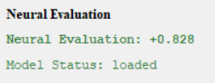
Figure 4: Neural Evaluation for the position shown in Figure 1

